_______________________________________________________

Build Instructions: Shoes Applicator

A shoe applicator to assist individuals with limited mobility to independently slide their feet in their shoes.

Developed by: Joanne Smith, Desiree Riny, Ian Firns, Annabel Pitt, Steve Hall, Amber Truong, Adele Easton, Stephen Kelly and Robert Layton.
_________________________________________________________________________
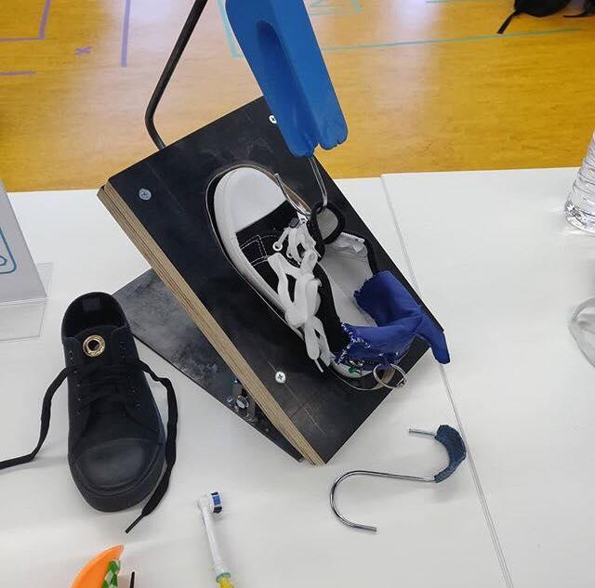

Approximate Cost: in $ Time Required: 2 days

General Warnings and Cautions
- Read through entire manual before attempting to build this device.
- Do not attempt a step if you are unsure of what you are doing. Certain steps in this manual require experience with fabrication tools. <<General Warning>>.

For assistance or clarification of any step, contact:

Ben Shemesh
Manager of Innovation and Development
Email: ben@tommelbourne.com.au
Website: aus.tomglobal.org
Mobile: 0412439048

Desiree Riny
Product Manager during event
Email: desireeriny@gmail.com
Website: desireeriny.com
Mobile: 0401241877

Steve Hall
Main Maker during event
Email:
Website:
Mobile:

User Assistance
For any questions regarding the assembly, operation or specifications of this device, please contact:
Ben Shemesh
Manager of Innovation and Development
Email: ben@tommelbourne.com.au
Website: aus.tomglobal.org
Mobile: 0412439048

Icon Glossary
The following icons may be used throughout this manual—each with its own purpose.
- Caution: The caution icon is used to signify whenever someone attempting the procedure may injure themselves or damage their equipment.
- Note: The note icon is used to signify useful bits of information that complement the instructions.
- Reminder: The reminder icon is used to provide information for after the procedure is completed, such as tips for disassembly.
- 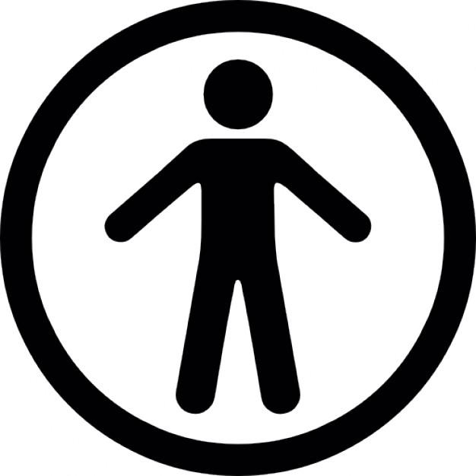 Need-Knower Specific: This part or method of manufacture has been designed specifically for a local Need-Knower.

Need-Knower Background:
Joanne is a 47-year-old with a neurological degenerative muscular disease which limits her mobility in her arms and legs. Joanne has trouble using her hands due to her flexed wrists and poor skin quality, making simple tasks incredibly difficult. Joanne would like a device to help hold her shoes open so that she can easily and independently slide her feet in.

Purpose of Device:
The purpose of the device is to assist individuals with limited mobility to independently to put and take off their shoes.

Physical Description:

An assistive shoe applicator that consist consists of three different components, which work in conjunction with another component that allows the user to be able to zip up their shoes and unzip their shoes.

- A shoe wedge
- A shoe horn
- A shoe tongue holder with hook or click

This assistive device only provides assistance to stabilize an individual shoe in the right angle, provide an application to slip the heel of an individual foot in the shoe and furthermore hold the tongue open. Do note for users in need of solution to that can assist to lacing up a shoe, please follow the instructions provided to build the device that work in conjunction with this assistive device for full capabilities of this assistive solution .

- Stable wedge platform: is used to stabilize an individual's shoe at an appropriate angle, so the user is able to independently slide their feet into their shoe, which is then assisted with a unique shoe horn .

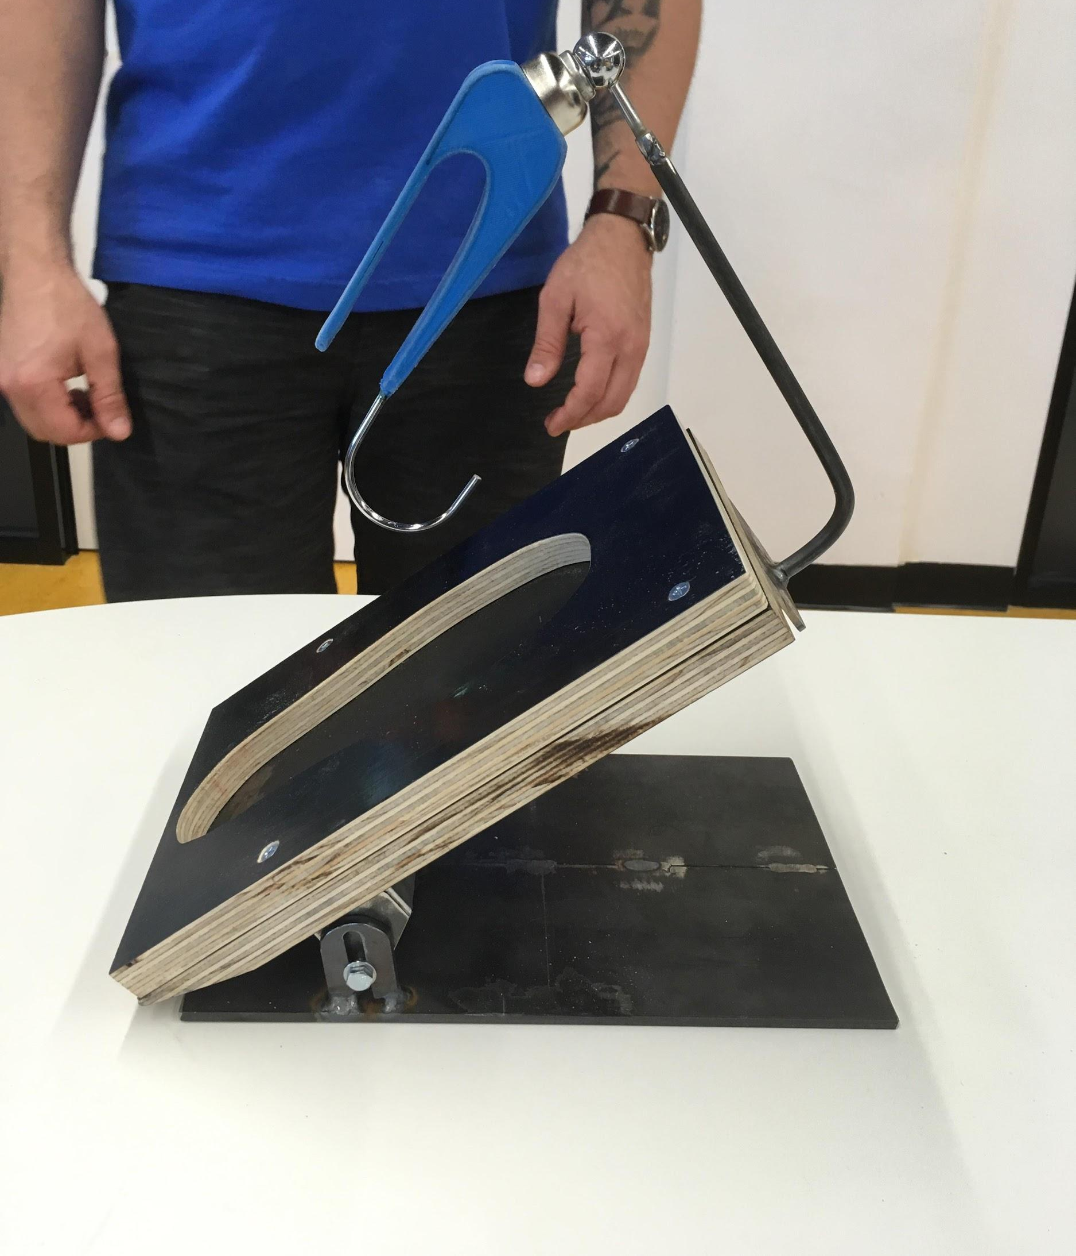
- Shoe Horn : The thermal form shoe horn, assist with the application of keeping the heel of the shoe open and allow the user to independently to be able to slide their heel of their foot inside the shoe without assistance, this also work in conjunction with a tongue holder that can help keep the tongue open .
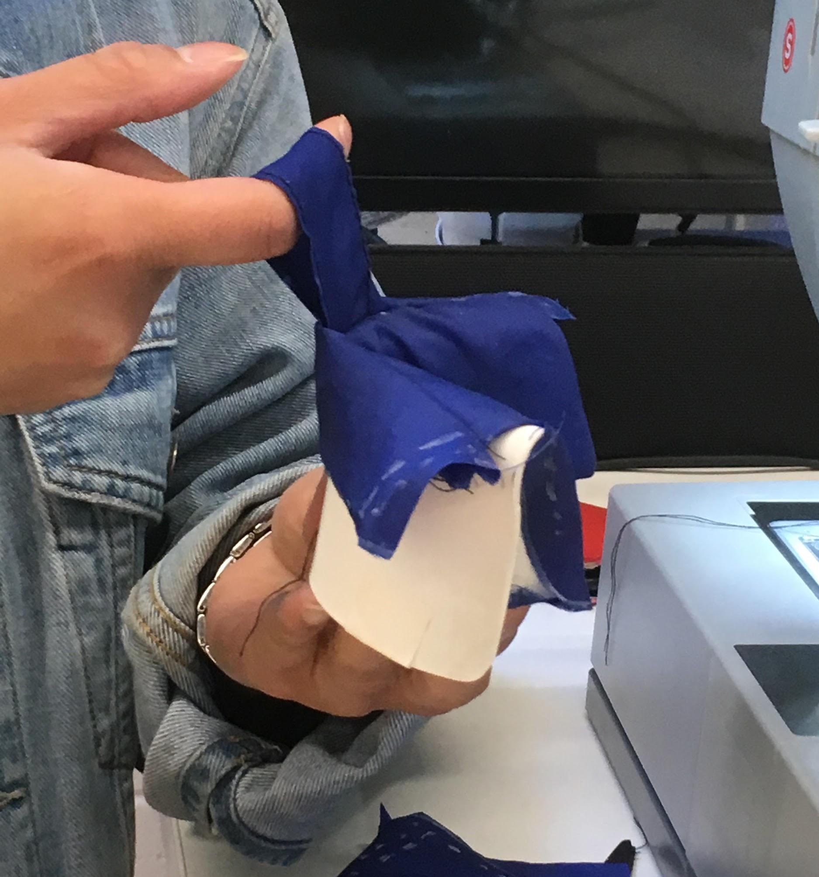

- Tongue holder : is used in conjunction with allowing user to pick up, move around and open the tongue of the shoe whilst keeping the shoe tongue open. This device can be made by both a hook or clamp handle, ultimate decision would be dependent on the individual's need

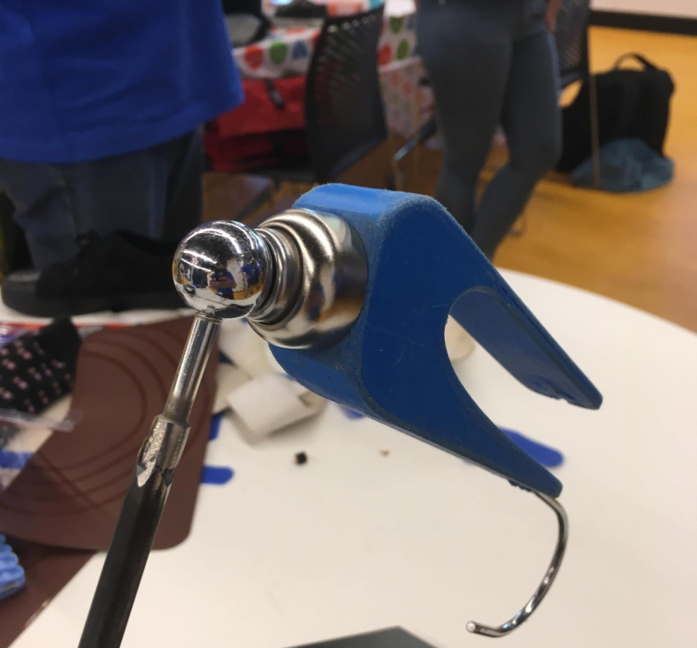

History of Development:
This project began at the 2019 TOM: Melbourne Makeathon at Ballarat. Joanne approached TOM as a need-knower looking for a solution to keep her shoes open so she can slide her feet in independently. A diverse group of makers consisted of designers, engineers and an occupational therapist came together to develop a solution for Joanne.
The Team first met in Pre-TOM in October to define solution requirements and analyse Joanne’s difficulties with sliding her feet into her shoes. Three requirements were identified. The solution was required to be:
- Executed on the floor
- Simple to perform
- Lightweight and portable
Two difficulties were found:
- Keeping the shoes opened
- Sliding her feet into her shoes
Joanne’s movement was also observed and taken into design consideration. For example, Joanne preferred to slide her feet into her shoes from the bottom up instead of top down since it gave her more stability. Through communication via social media and the second meeting before the makeathon, the Makers worked together to brainstorm potential solutions for Joanne. The Team came up with a number of ideas and built multiple prototypes to be tested on Joanne during the makeathon days. These consisted of different types of seating platforms, shoe holders and shoe horns. Some available assistive products were also purchased for testing. Ultimately, the Team aimed to build a solution that can be easily adapted into her living condition and ensure her safety always being prioritised.
On Saturday the 23rd of November, the makeathon initiated and the Makers had an opportunity to test their prototypes and receive Joanne’s feedback. The feedback had enabled the Team to narrow down their ideas and refine their designs. A number of design features were examined and confirmed:
- The solution should include three components: a seating platform, a shoe wedge and a shoe horn.
- There should be a back support for Joanne’s seating platform.
- The seating platform should be elevated above the ground.
- The shoe wedge should be adjustable in terms of the inclining angle and can hold shoes from both sides.
- The handle for shoe horn can be made to be similar to that from Joanne’s toothbrush handle.
- The shoe tongue can be opened by making an eyelet on the tongue and hooking it to the shoe holder using magnet.
Furthermore, the Team also worked closely with other TOM team, who was working on Joanne’s shoes laces tightening solution to ensure the two solutions integrated well together.
By the afternoon of the 23rd, the first iteration was tested. A number of adjustments were made:
- The seating platform was no longer needed.
- The hooking eyelet was discarded as it was difficult for Joanne to hook the eyelet.
- Resistant materials attached to the bottom of the shoe wedge was discarded as they made it difficult to Joanne to move the wedge around.
- The shoe holder on the wedge could be replaced with a rubber/silicon mat attached to the wedge surface to stop the shoes from sliding off.
- The shoe horn would be wrapped with a layer of fabric to protect Joanne’s skin.
- The solution was modified to have three main components: a shoe wedge, a shoe horn and a shoe tongue holder.
The second day of makeathon was dedicated to implement the feedback and develop the final solution to Joanne.
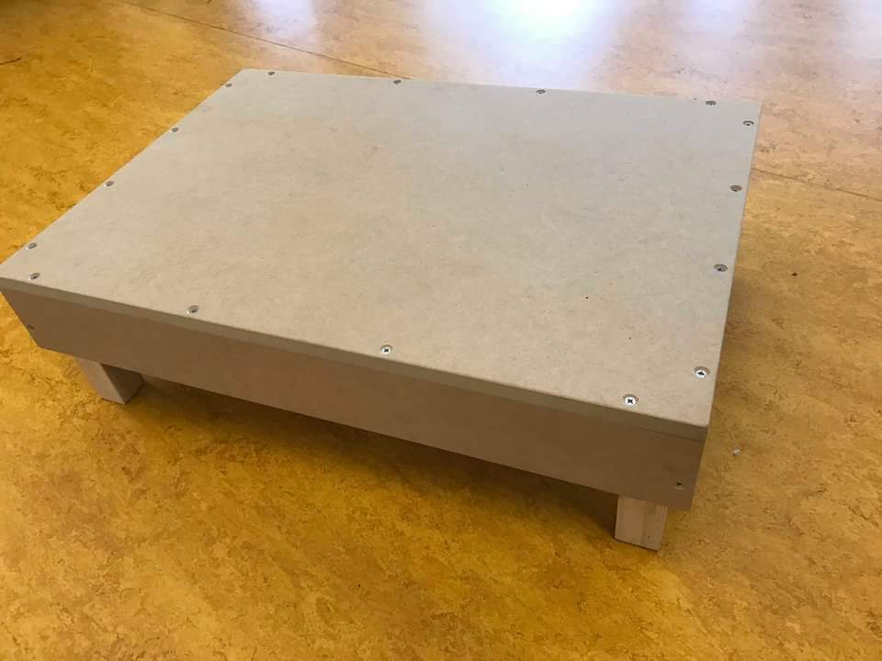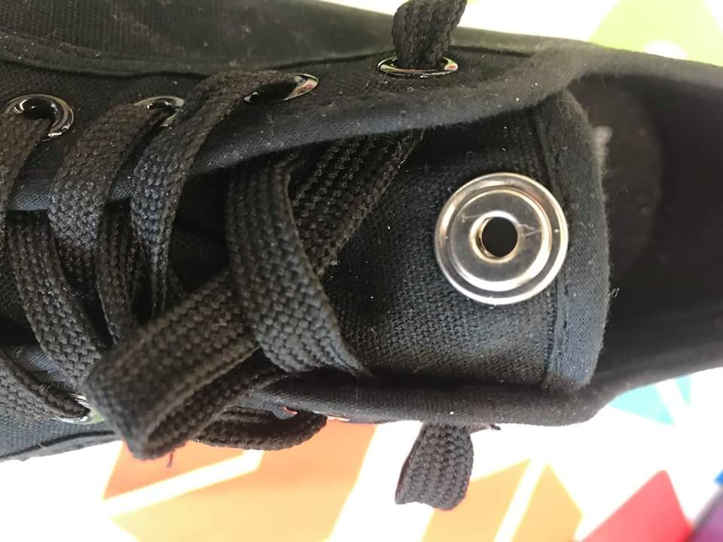
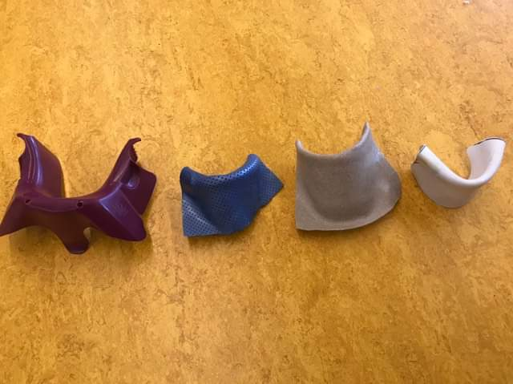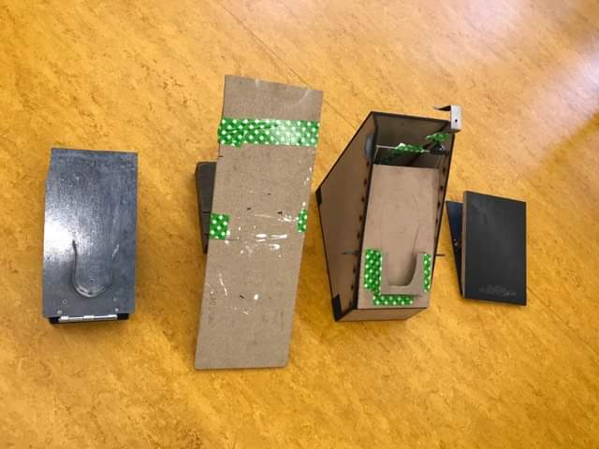
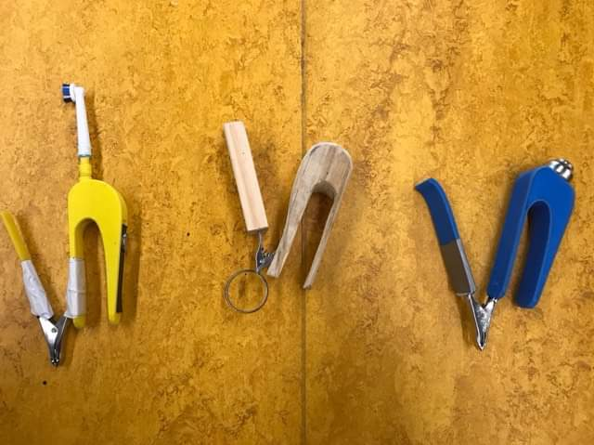

Bill of Materials
Part ID | Part Name | Description | Qty | Units | Supplier | Unit Cost | Cost
A | PVC pipe | 90mm SWP901 | 1m | 1m | Bunnings Warehouse | $7.92/m | $7.92
B | J Hook | Pinnacle White Small J Hook | 1 | 1 | Bunnings Warehouse | $3.10 | $3.10
C | Magnetic sphere door stop | Magnetic | 1 | 1 | Bunnings Warehouse | $3.19 | $3.19
D | Grommet Tool Kit | 10mm | 1 | 1 | Bunnings Warehouse | $19.98/pack | $19.98
E | Butt Hinge | 100mm single loose pin butt hinge | 1 | 1 | Bunnings Warehouse | $3.50 | $3.50
F | Steel angle | 40 x 40 x 5 mm 2m steel angle | 1 | 1 | Bunnings Warehouse | $25.55 | $25.55
G | Bolts and Nuts | Pinnacle M6 x 60 mm Stainless Steel Hex Head | 1 | 6 | Bunnings Warehouse | $6.21/pack | $6.21
H | Plywood | Project Panel 1200 x 897 x 7 mm Premium Grade Radiata Plywood | 1 | 1 | Bunnings Warehouse | $25.00 | $25.00

Tools Required:
- Circular saw
- Grinder
- Sewing machine
- Heat gun
- 3D printer and CAD software
- Hand tools : Screwdriver, file, spanner
- Welding Equipment
- Nuts and Bolts

Parts Inventory (Assembly) :

Part No. | Part Name | Description | Qty | Units
A | Shoe horn | A customised thermal form sheet with a removable medically graded fabric cover that assist with spreads the heel of the shoe open, to help users to easily guide their feet within the shoe. | 1 | 1
B | Shoe tongue holder | A handle with a 3D printed handle with an embedded metal hook that can hook to an attached eyelet on the shoe tongue to keep it open, to assist users to slide their feet in their shoes easily. | 1 | 1
C | Shoe wedge | A platform with a foot holde tilted at an angle to provide stability and assistance to users slide the feet into their shoe easily. | 1 | 1

Assembly drawing with parts numbers :

Assembly

Step 1 : Title
- Insert Step Description
- Insert Image
- Link: Insert link

Step 2 : Title
- Insert Step Description
- Insert Image
- Link: Insert link

Step 3 : Title
- Insert Step Description
- Insert Image
- Link: Insert link

Step 4 : Title
- Insert Step Description
- Insert Image
- Link: Insert link

Step 5 :Title
- Insert Step Description
- Insert Image
- Link: Insert link

Step 6 : Make the cover for the shoe horn

- Insert Image
- Link: Insert link

