________________________________________________________

Build Instructions: ‘ Push n Swivel ’

Custom design resistance and cardio exercise device

Developed by: Mary Henley-Collopy, Desiree Riny, Josh O’Connell, Joel Kuper, Becky Rothfield, Simon Sostaric, Penina Gunzburg, Joanna Pearce, Agnes Kusnadi, Nick Perillo
_________________________________________________________________________

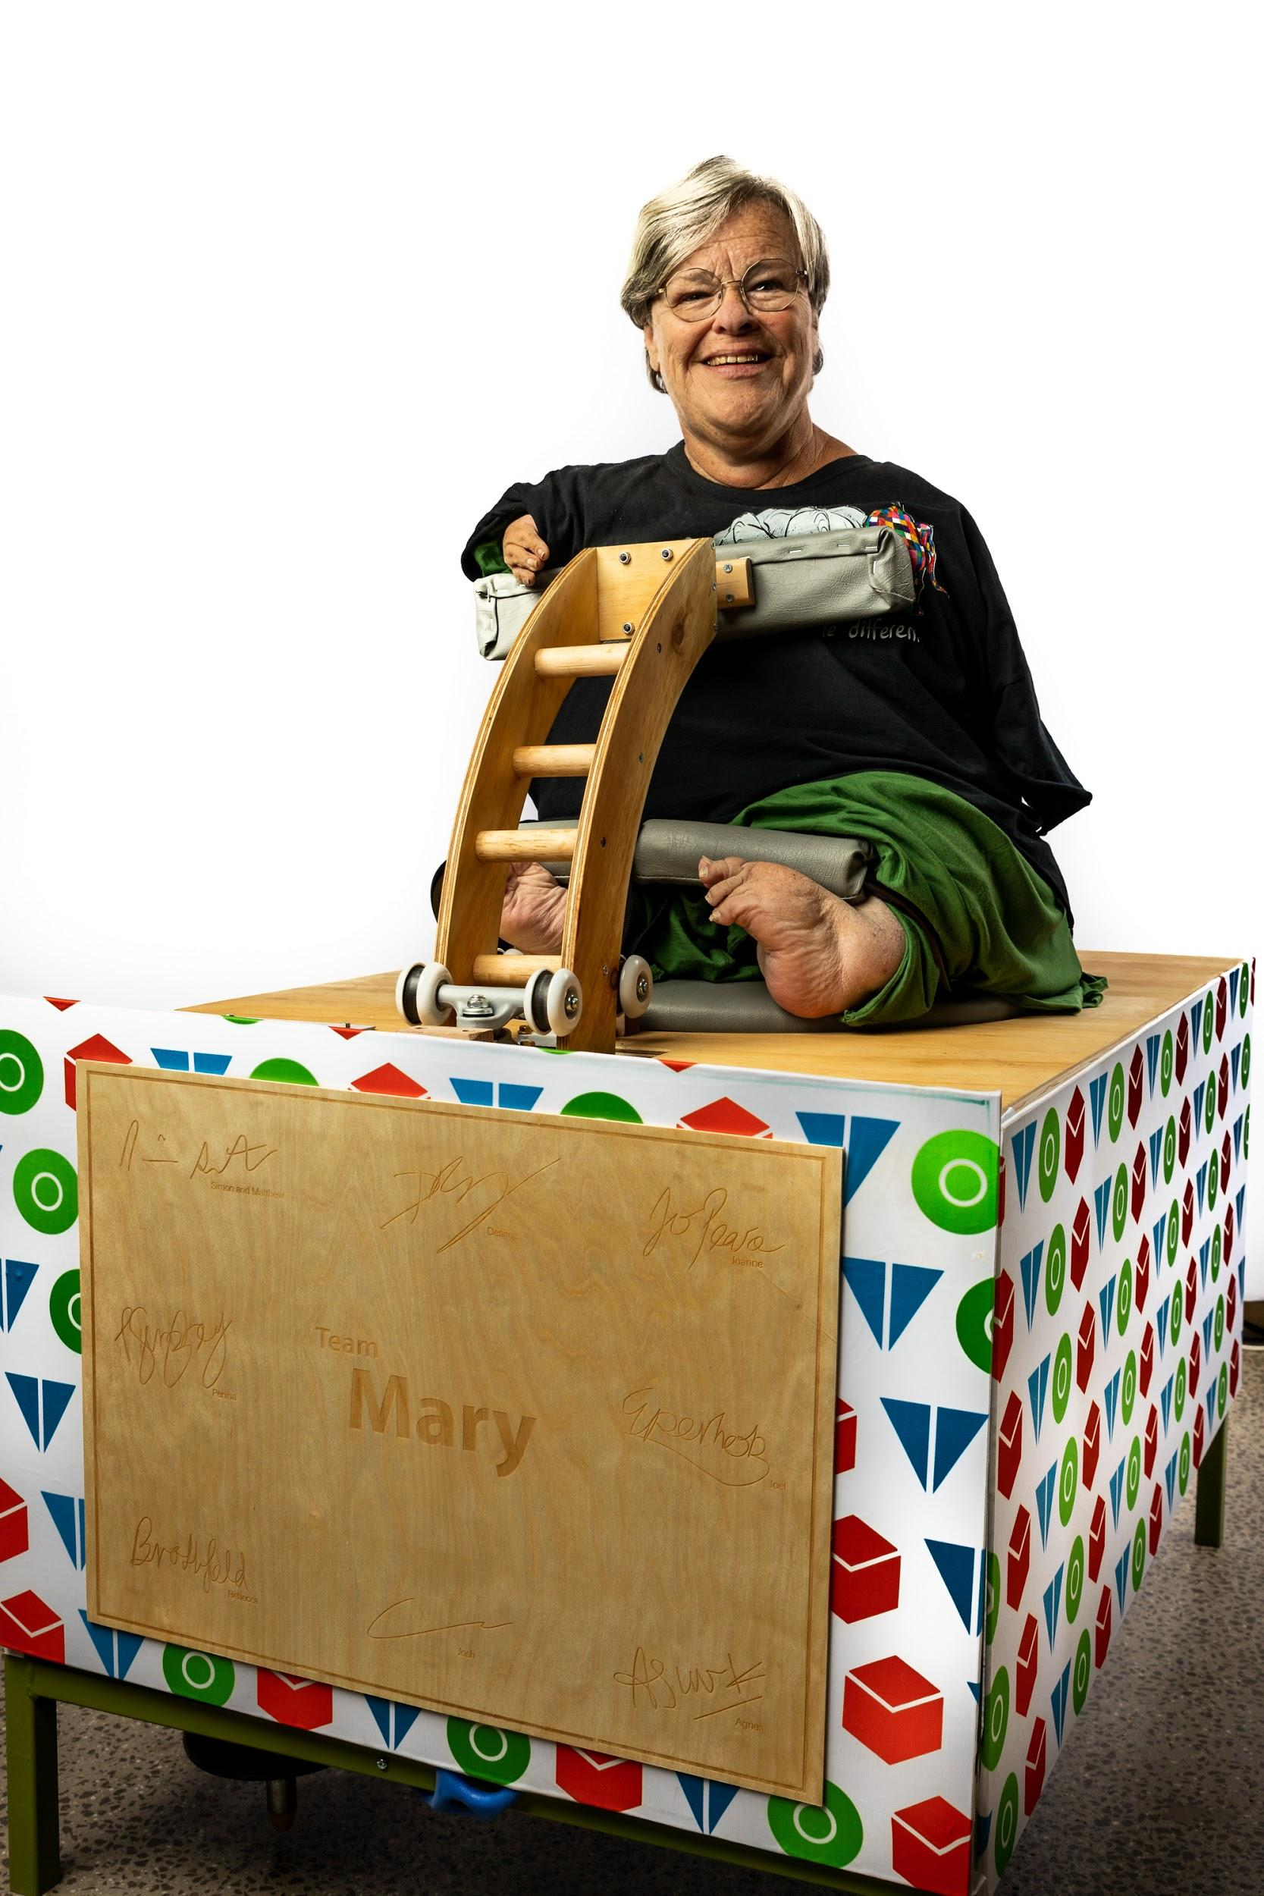
Approximate Cost: Time Required: 1-2 weeks
General Warnings and Cautions
- Read through entire manual before attempting to build this device.
- Do not attempt a step if you are unsure of what you are doing. Certain steps in this manual require experience with fabrication tools. <<General Warning>>.
  - For assistance or clarification of any step, contact

User Assistance
For any questions regarding the assembly, operation or specifications of this device, please contact: hello@tomglobal.org or contact: Desiree Riny , Josh O’Connell, Joel Kuper
Icon Glossary
The following icons may be used throughout this manual—each with its own purpose.
- Caution: The caution icon is used to signify whenever someone attempting the procedure may injure themselves or damage their equipment.
- Note: The note icon is used to signify useful bits of information that complement the instructions.
- Reminder: The reminder icon is used to provide information for after the procedure is completed, such as tips for disassembly.
- Need-Knower Specific: This part or method of manufacture has been designed specifically for a local Need-Knower.

Need-Knower Background:
Mary Henley-Collopy is a retired Social Worker, who has a zest for living and is very active in her community. Exercise and fitness has always been a challenge for Mary as generic fitness equipment does not suit Mary’s needs. As a result Mary, sought the expertise of Simon Sostaric who is an exercise physiologist in Melbourne, Australia. Mary and Simon have been exercising together on average twice weekly for the last 15 months. For Mary to go further in her fitness goals, both Simon and Mary realised customised equipment would be needed to facilitate independent practice but nothing has ever existed on the market. Simon nominated Mary’s challenge of developing a bespoke exercise device to provide opportunity to undertake regular , independent cardiovascular and strength training.
Purpose of Device:
Push and Swivel is a device that allows the user to exercise cardiovascular and resistance workouts independently within the comfort of their own home. This device is intended for users who capabilities to swivel their torso to either side, and undulating sliding up and down.

Physical Description:
Insert the physical description
List Main parts in dot point
Insert Image

History of Development:

This project began at the 9th April 2019 at FAB9 Footscray, Victoria for assistive technology organized by Tikkun Olam Makers (TOM). The concept arose from exercise physiologist (Simon Sostaric) who envisioned an all-of-body exercise apparatus that can be used independently outside of formal exercise sessions. The concept was to enable Mary to step-up her exercise routine to the next level, i.e. most other days of the week. This is due to Mary’s inability to exercise independently without 1:1 support. It was important to ensure Mary’s cardiovascular and resistance training being incorporated into her weekly routine at home.
Mary began exercise physiology sessions in March 2018, as she could not access and negotiate generic gymnasium equipment, and there was nothing commercially available to suit her double amputee disabilities. Hence why this machine was designed and developed, to allow Mary to become more independent in maintaining her fitness and taking control over exercise routine within the comfort of her home, without constantly being dependent on visiting Mr. Sostaric to maintain her regular exercise.

Tools Required:
Electrical tools: Drill, Spanner set, Driver (phillips screw driver), Circular Saw
Outsourced Manufacturing: CNC Manufacturing, Metal Welding, Table saw , Sewing Machine
Hand tools : Clamps, spanner, phillips screw driver, staple gun
Adhesives: Epoxy Resin and PVA glue .
Electrical Equipment : Soldering iron, Wires, bread board, Arduino MicroController, Laptop

INSERT TECHNICAL DRAWINGS AND SUB ASSEMBLIES SO USER CAN REFER BACK

Bill of Materials

PART ID | PART NAME | DESCRIPTION | QTY | UNITS | SUPPLIER | UNIT COST | COST
A1.1 | Table Top Base | Table Top Base .DXF file | 1 | 1 | Bunnings  12mm x 1200 x 897 plywood | $36 | Including CNC cut within end price may vary
A.1.2 | Middle Bae |  | 1 | 11 | Bunnings  12mm x 1200 x 897 plywood
B1 | Table Frame | Metal Square Structural Hollow rods (SHS) table frame | 1 |  | Bunnings  30 x 30 x 3 mm Metal SHS | $100 | Including the service of welding price may vary
C1.1 | Swivel Seat | Swivel Seat.DXF file | 1 | 1 | Bunnings  12mm x 1200 x 897 plywood | $36 | Including CNC cut within end price may vary
C1.2 | Swivel Seat Base |  | 1 | 1
D1 | Pivotal Rod | Metal cylindrical rod that is attached to Swivel Seat | 1 | 1 |  |  | Including the service of welding price may vary
E1.1 | Resistance Arm | Resistance Arm.DXF file | 2 | 1 | Bunnings  12mm x 1200 x 897 plywood | $36 | Including CNC cut within end price may vary
E1.2 | Resistance Arm Cap | Resistance Arm Cap.DXF file | 2 | 1 | Plywood used for Resistant Arm can be cut from the same material |  | Including CNC cut within end price may vary
E1.3 | Dowel Joints | Dowel joinery for assembly of 2 resistance arms | 7 | 1 | Bunnings  1.2x9.5 mm dowel | $2.62

Bill of Materials for (OEM) Parts
PART ID | PART NAME | DESCRIPTION | QTY | UNITS | SUPPLIER | UNIT COST | COST
A2 | Extension spring C-323 | Extension springs will be attached to the Piviotal Rod and table frame | 4 | 4 | Bunnings | $9.52
B2 | Eye bolt Zenith | Will be attached around the table frame and Pivotal Rod | 1 pack (6 pcs | 1 | Bunnings  Eye bolt zenith 6x100x14mm | $9.66 | $9.66
C2 | M8 threaded rod | Threaded M8 rod in which will be attached to Pivotal Rod | 1 | 1 | Bunnings
D2 | Castor 50 mm wheels | The castors were used to activate rotation function for the swivel seat | 4 | 4 | Bunnings | $4.70 | $8.80
E2 | Castor  75mm | The castors were used to activate rotation function for the swivel seat | 4 | 4 | Bunnings | $6.00
F2.1 | C-shape Foot Bar | C-shape Foot Bar padded metal bar, taken from a 4 wheeled walker with seat. | 1 | 1 | N/A | N/A | N/A
F2.2 | Vinyl | Vinyl used for the swivel seat covering | 1 | 1 | Spotlight  1000 x 1370 mm | $15 | $15
F2.3 | Wadding | Wadding used for the swivel seat cushioning | 1 | 1 | Spotlight  1000 x 510mm | $10 | $10

Assembly

Step 1 : Table Top Base & Middle Base
Parts: Table Top, Middle Base
Tools & Materials : CNC, Jig Saw

1. Download Table Top .DFX file and get the table top CNC
2. Cut Middle Base, Using Circular Saw - Refer to technical Drawings for measurements

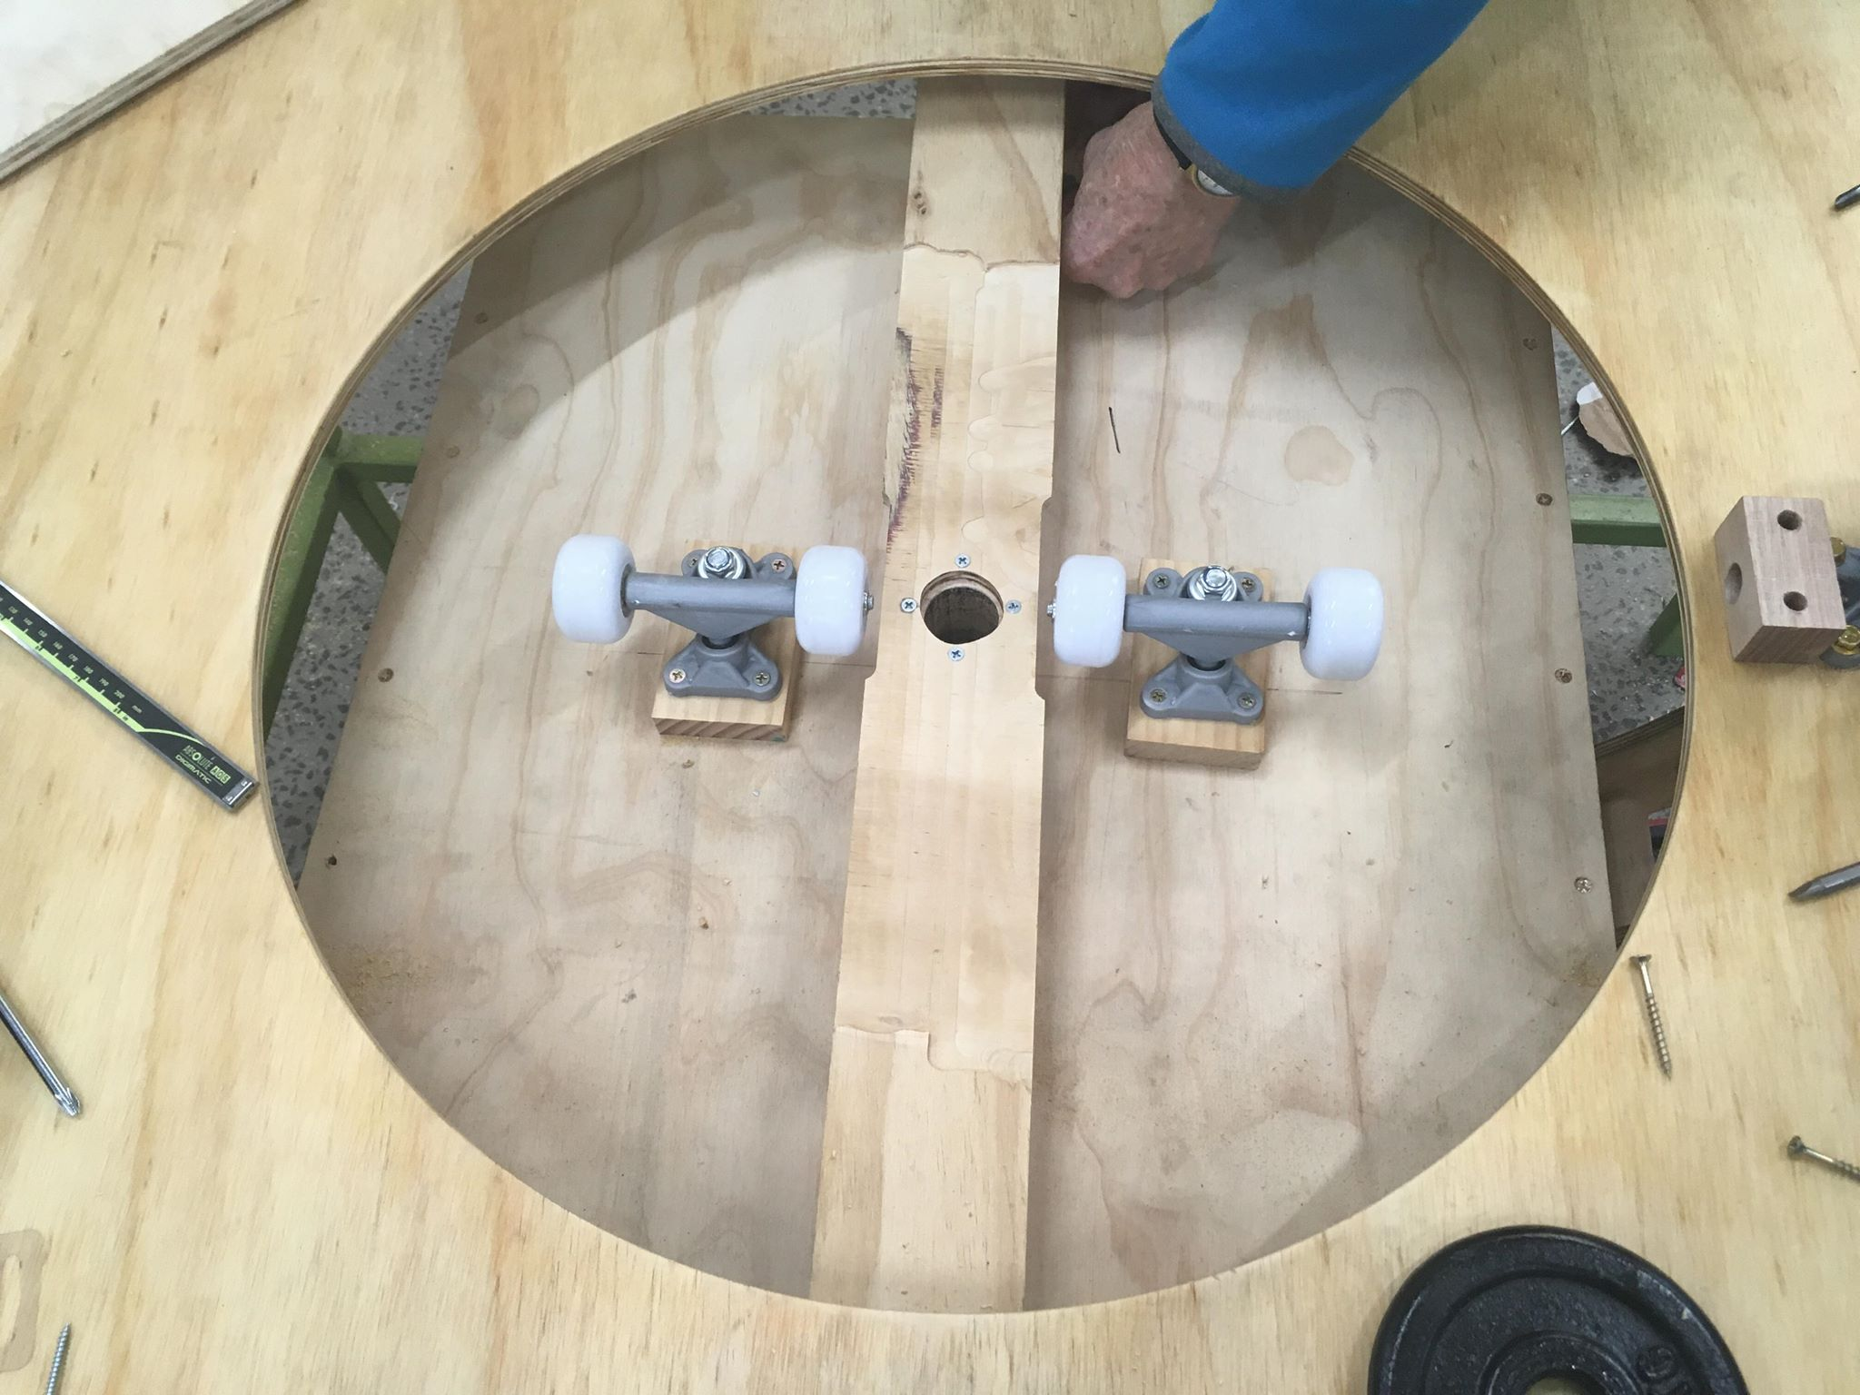
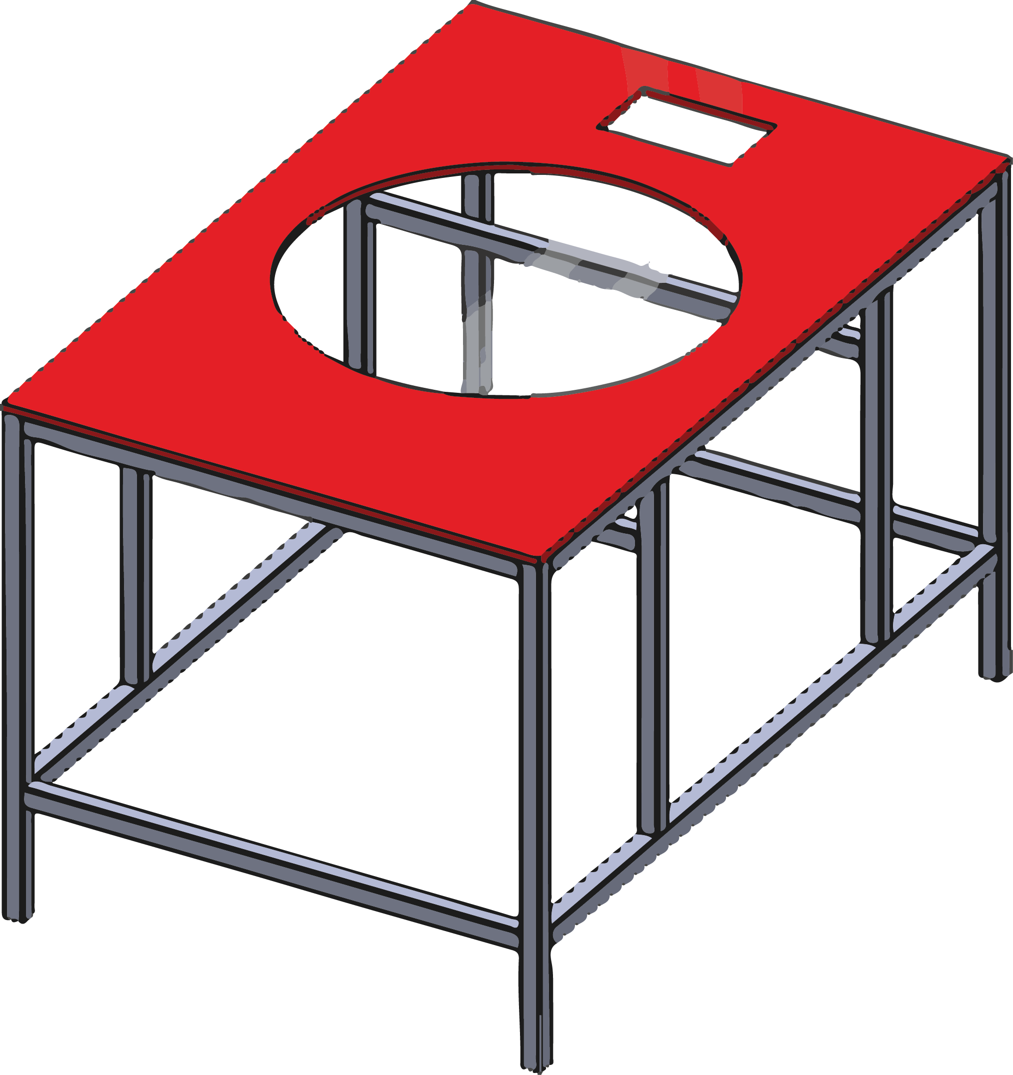

Step 2 : Table Frame Assembly

- Cut all Metal Square Structural Hollow rods (SHS) to appropriate size according to technical drawings and using appropriate tools to cut
- Outsource Welding
- Spray Paint
- Use self tapping screws and drill holes to assemble both
Table Frame, Table Top Base and Middle Base

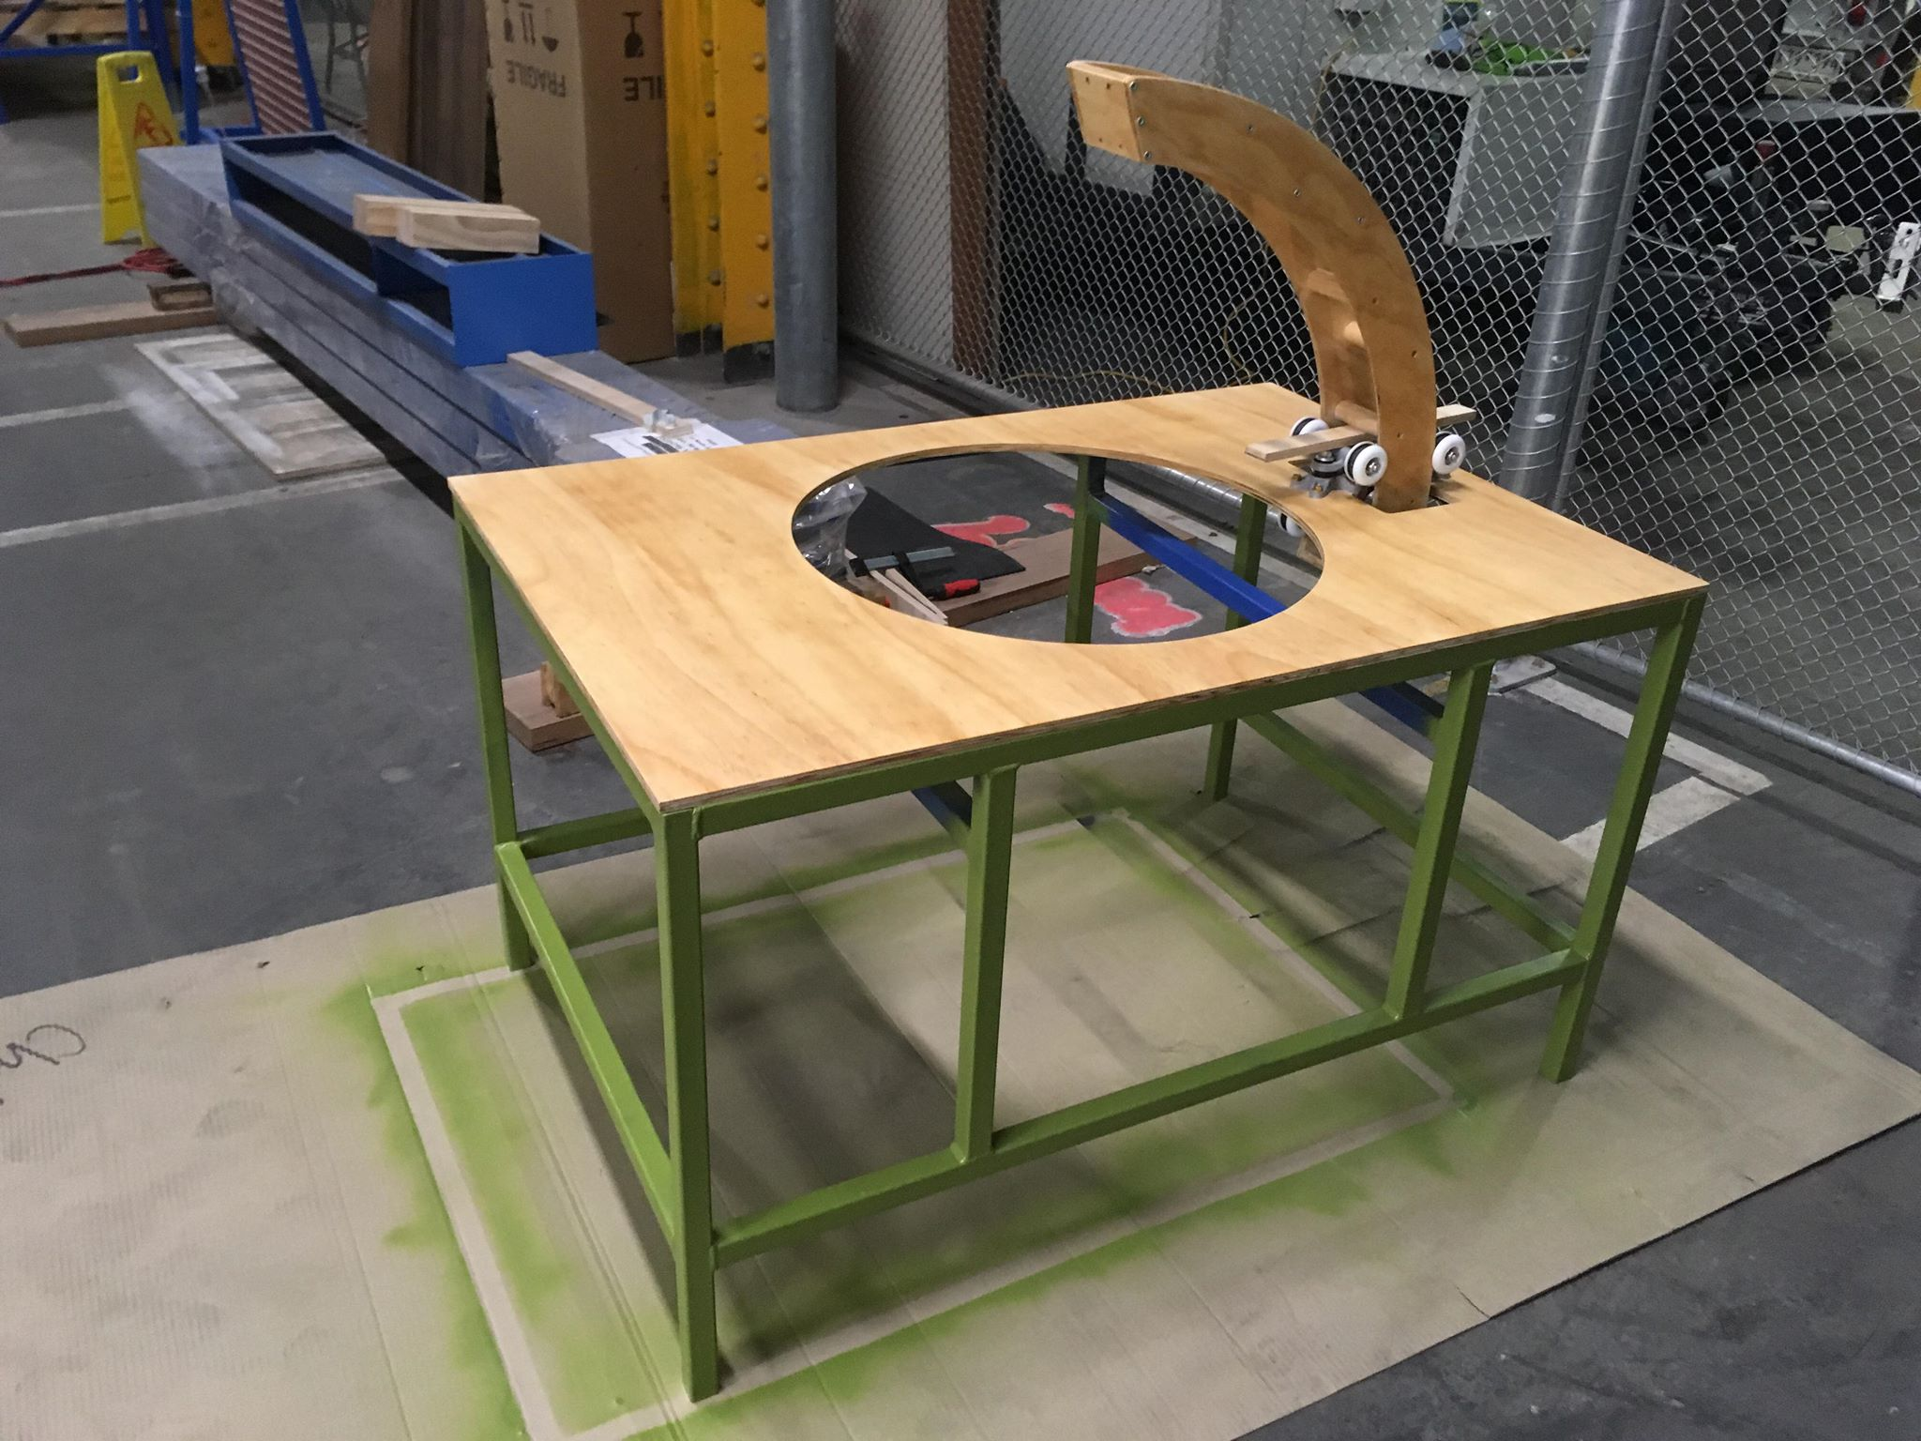
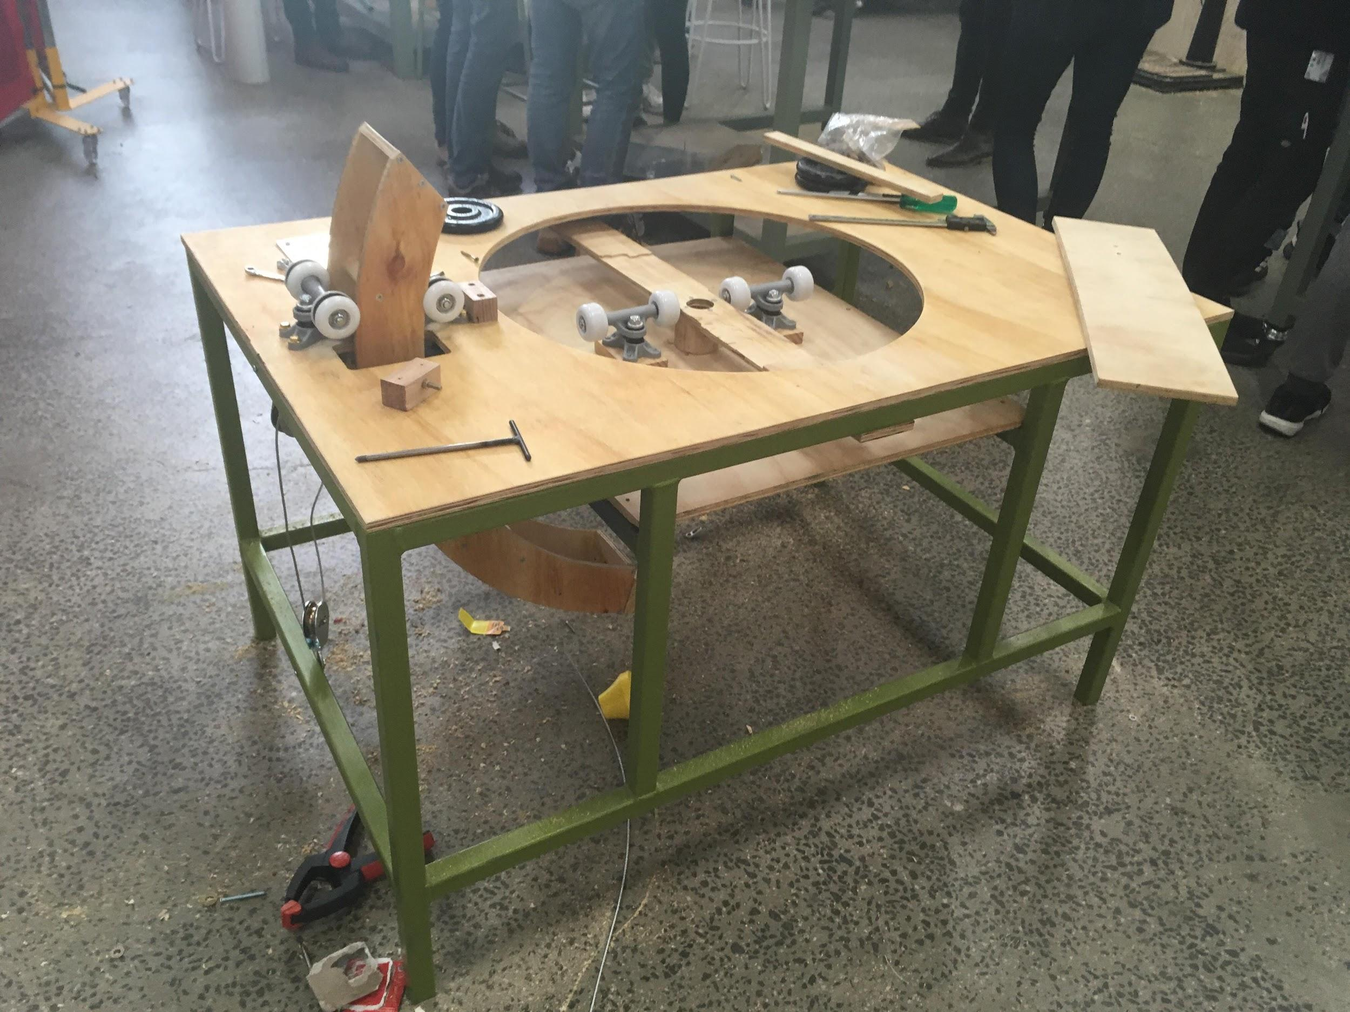
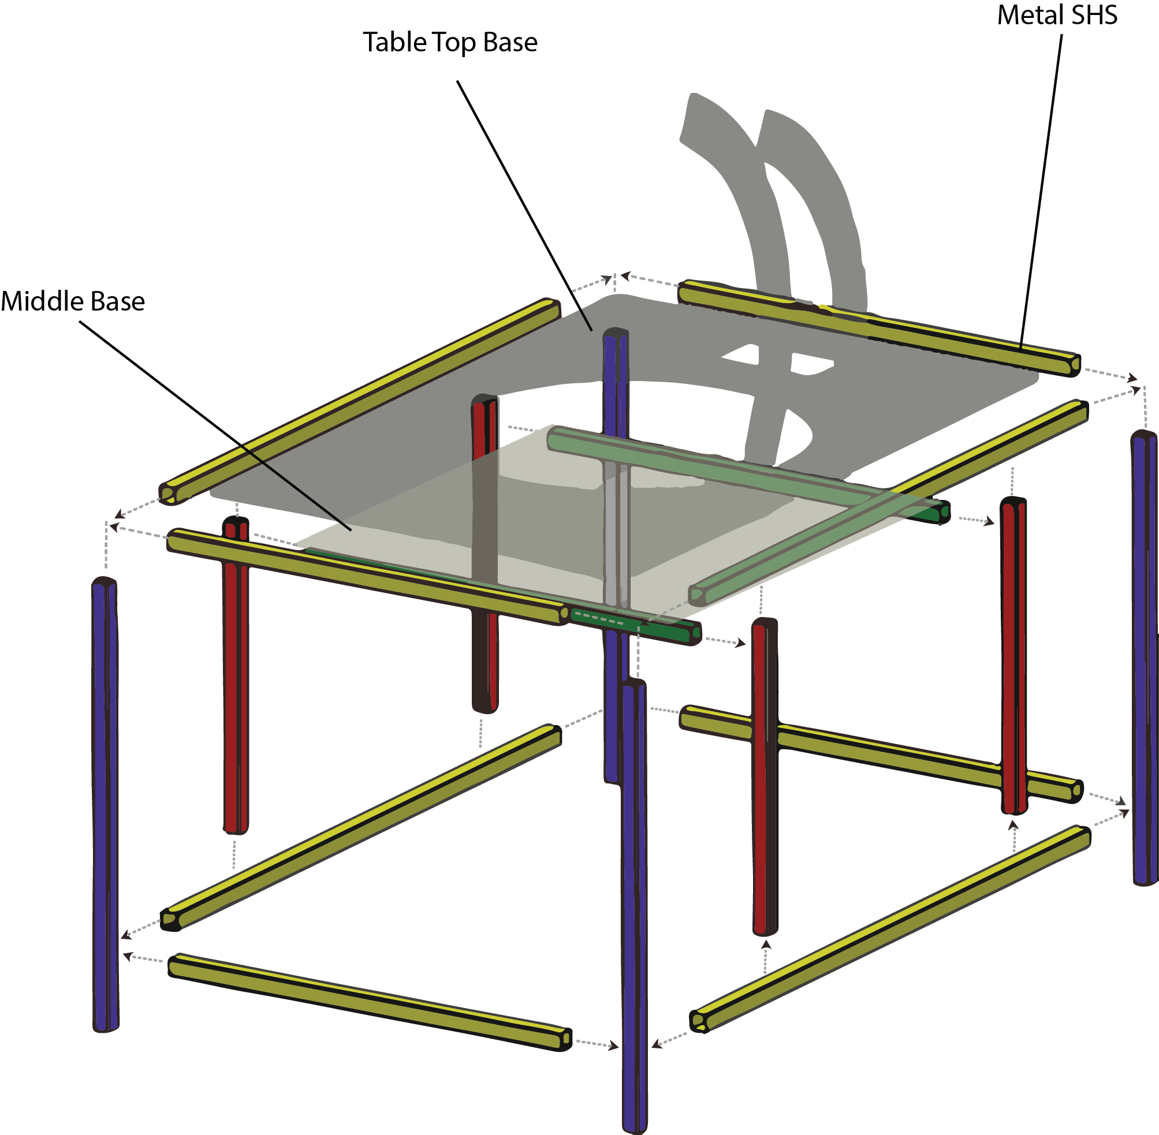

Step 3 : Swivel Seat & Base
Parts: Swivel Seat
Tools & Materials : CNC, Staple Gun, Wadding, Vinyle, Plywood

- Download Swivel .DFX file and get the seat CNC
- Measure the person’s widest size. Seat size: 600mm diameter
- Cut wadding and vinyl to size
- Wrap around the vinyl, and staple gun the edge of the vinyl to the plywood
- Once the above steps completed, attached the C-shape metal bar to the seat. Use xx size bolt

INSERT IMAGE ASSEMBLY

Step 4 : Assemble Pivotal Rod & Swivel Seat
Parts: Swivel Seat, Pivotal Rod, M8 Threaded Rod
Tools & Materials : CNC, Staple Gun, Wadding, Vinyle, Plywood
- Cut Metal Rod to Length of the rod according to technical drawing
- Cut Metal Disc and then weld together rod and disc
- Drill hole for M8 Metal Threaded Rod according to technical drawing
- Then cut M8 Metal Threaded Rod Length
- Drill holes within the base of Swivel Seat
- Using M8 screws attach the Swivel Seat and Pivotal Rod

INSERT IMAGE ASSEMBLY

Step 5 : Resistance Arm
Parts: Resistant Arm x2 , Resistant Arm Cap x2, Wooden Dowel Joint x7
Tools & Materials : CNC, Drill, Driver, Wood Screws x25

- Download Resistance Arm .DFX File & Resistance Arm .DFX File
- Get the files CNC
- Cut 7 Dowel Joints LXWx D
- Assemble resistant arm together with wood screws

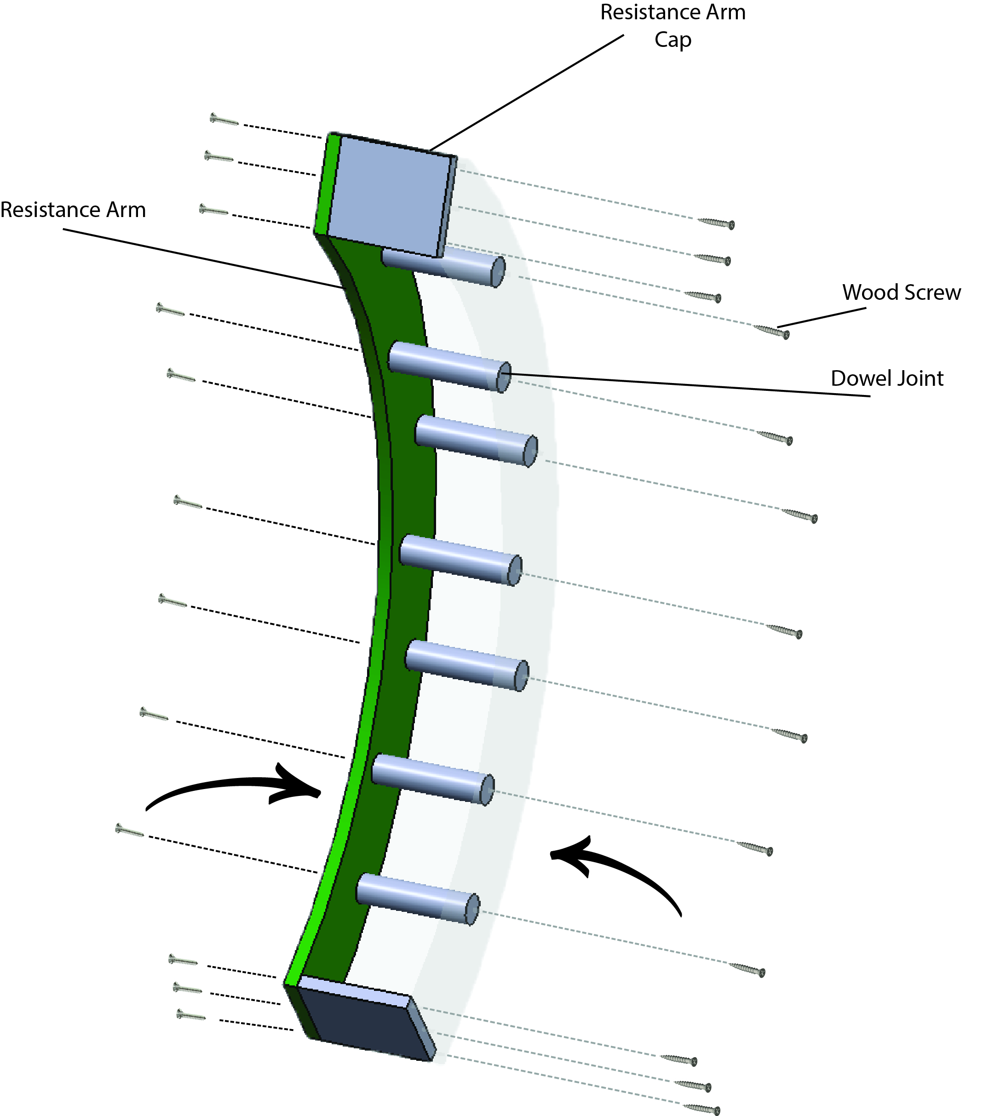

Step 6: Castor Wheel, Resistance Arm and Guide Box Assembly
Parts: Resistant Arm Assembly from Step 6, Castor Wheels
Tools & Materials : Drill, Driver, Wood Screws, Castor Wheel s
- Download GuideBox.DFX File
- Drill pilot holes for wood screws
- Drive screws in place to hold the Castor Wheels first . Ensure that the Castor wheels align up with the Resistant Arm . Make adjustments if it doesn't .
- Place the Resistant Arm through the opening of the Table Top, using the castor wheels as a guide
- Begin to assemble the Guide Box referring to technical drawing.

DELETE AFTER FINISH Parts Inventory (Assembly) :

Part No. | Part Name | Description | Qty | Units
A | Castors  50 mm | 50mm grey rubber fixed castor | 12
 | Castors  75mm | 75 mm grey rubber fixed castor | 4
 | Plywood  12 mm | 1200 x 900 x 12 mm | 2
 | Metal SHS | 30 x 30 x 3 mm.  The Metal SHS was used to build the scaffolding ‘table’ frame as the based of the device. | 1
 | MDF  9mm | 450mm x 1200 mm  MDF board used as ‘curtaining’ for dust protection (optional). | 1
 | vinyl | 1000 x 1370 mm  Vinyl used for the swivel seat covering | 1
 | Wadding | Extra Firm Stabilizer wadding  Wadding used for the swivel seat cushioning | 1
 | C-shape metal bar | C-shape padded metal bar, taken from a 4 wheeled walker with seat. | 1
 | Extension spring C-323 | Extension spring used at add resistance on the swivel board. | 4
I | Wires | Assortment of wires, to wire arduino , breadboard and LCD display | 1-20
J | Arduino | Electronic board that control feedback from LCD display | 1 | $2.00
K | Hall effect sensor  Button | Sensor which detects a magnetic field and buttons to control feedback sensor | 1  2 | $7.75- 8.00
L | LCD Display | 10 x 60 mm
M
N

